DART Electric Bus Recap
Google Analytics
Oct. 1 – Dec. 9
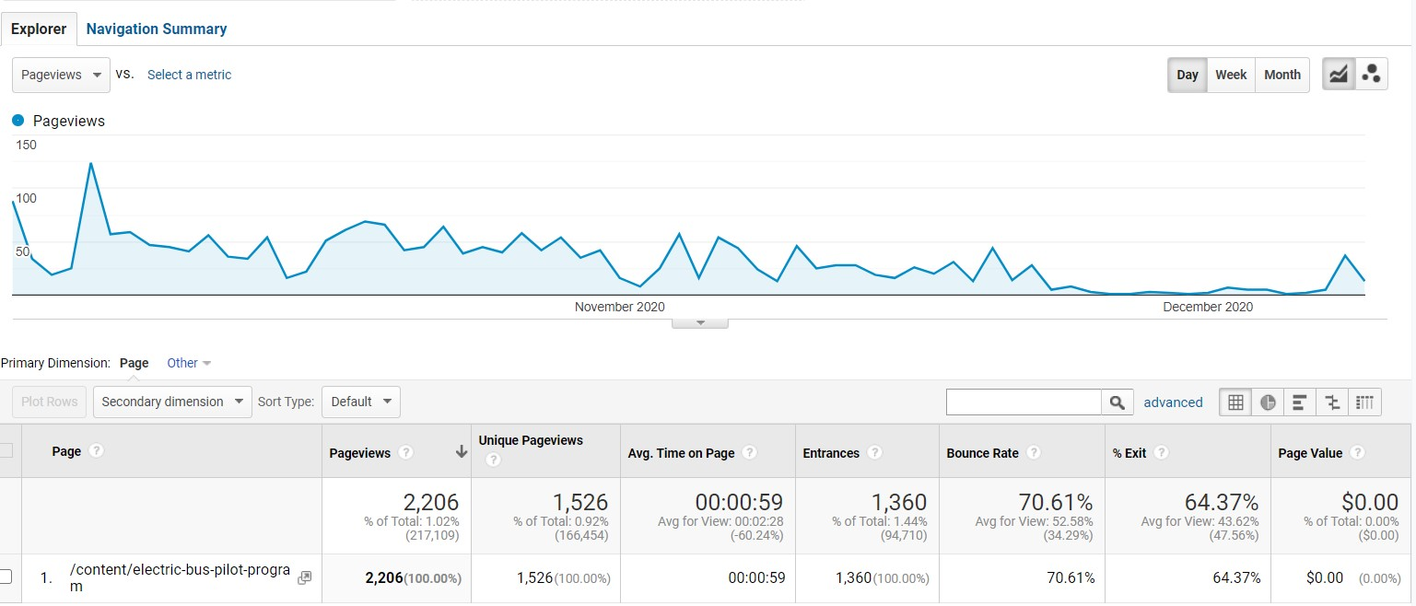
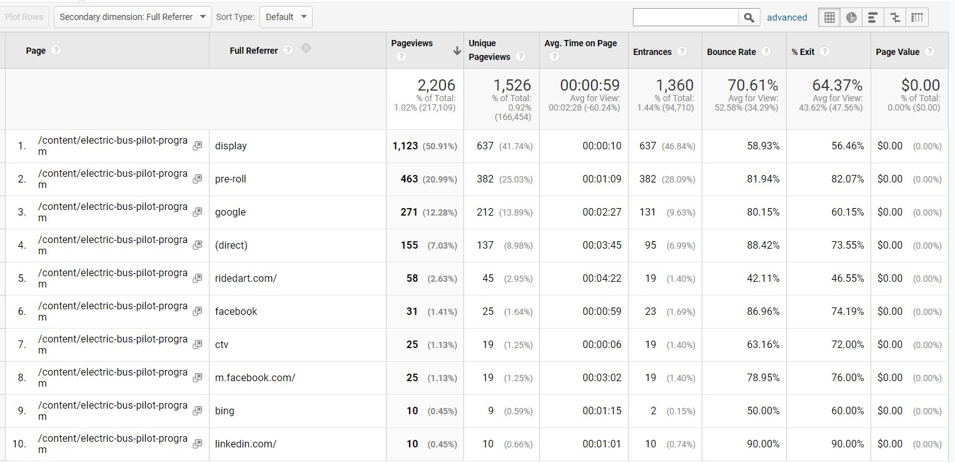
Dec. 8 – Jan. 11
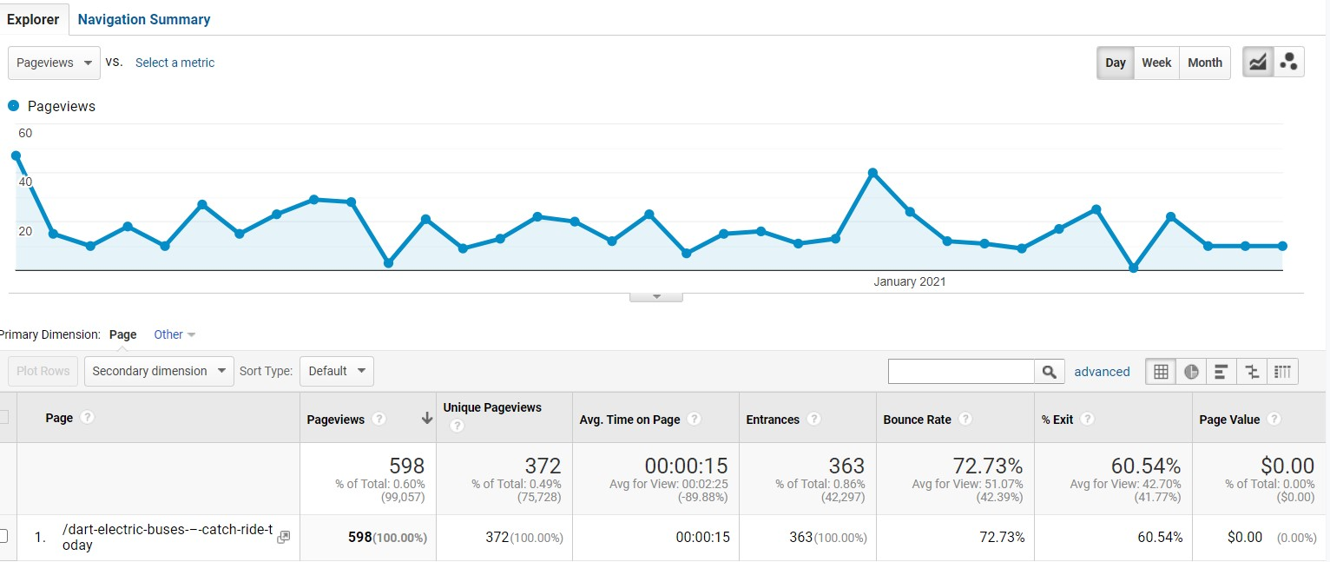
Social Media
Facebook
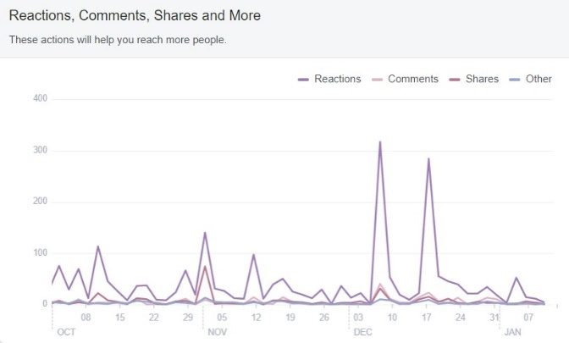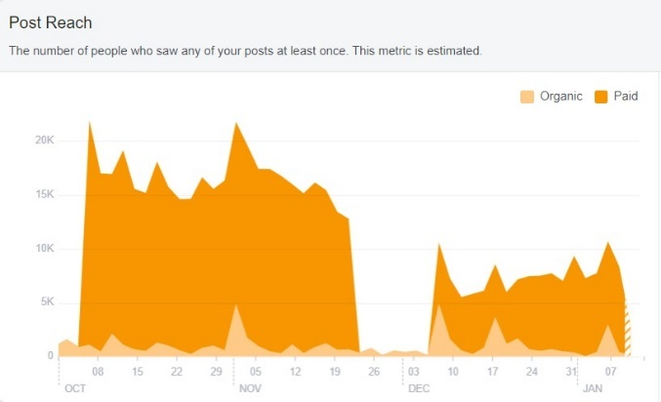
Twitter (17 tweets)
Engagements: 2,667
Impressions: 42,446

Instagram (5 posts)
Likes: 236
Reach: 1,001
Impressions: 1,602

