

**2019 APTA Bus Safety Excellence Awards**

### Introduction:

### 

### Omnitrans is the transportation provider for the San Bernardino Valley in Southern California. The agency provides public transportation services for our community with 30 fixed routes, a bus rapid transit (Green Line) route, 3 express routes and demand response service to over 456 square miles in the service area. Omnitrans’ service fleet includes 190 New Flyer coaches. In fiscal year 2018, the agency transported over 11 million passengers, while traveling 9.15 million revenue miles annually.

### Omnitrans has fifteen, 60-foot, 5-door CNG articulated coaches that operate on the bus rapid transit sbX Green Line route. It operates a 16-mile-long route from Loma Linda Hospital & University to California State University San Bernardino. sbX operates at center running and curbside stations and accesses numerous transfer points, including the San Bernardino Transit center (SBTC) and Metrolink trains. It operates every 10-15 minutes with 60,000+ monthly boardings Monday through Friday, with Saturday service added in January 2019.

### Omnitrans’ demand response fleet has 106 paratransit vans throughout its service area. The agency also operates seven community shuttle routes with its Omni-Go service. These services provide 380,000 passenger trips annually to senior and ADA customers.

### 

### 

### 

### Safety Culture – New Coach Operator Training Program:

### At Omnitrans, safety culture is our number one priority! Our student coach operator training is very thorough. All student coach operators go through an extensive six-week training program. Initial classroom training consists of a review of all agency rules, regulations and safety laws, the National Safety Council eight-hour Defensive Driving Certification course and the Transit and Para-Transit (TAPTCO) coach operator development course. Our classrooms have interactive whiteboards *and* a coach simulator to enhance the training experience.

### 

### 

### *Students try out their skills on the simulator, which mimics various types of driving hazards and challenging situations.*

### 

To prepare for DMV testing, there are three initial drive days as part of the process. Additional practice and testing, as well as training on all coach equipment (including ADA securements), are included in the process. The classroom training portion concludes with a six-section written test that student coach operators must pass with an 80% score or higher before moving on to behind-the-wheel route training.

### 

### Our route training includes an invaluable behind-the-wheel experience. All student coach operators must operate the coach on all routes throughout our service area. The students are trained by experienced coach operator instructors (C.O.I.s), which are the cream of the crop of Omnitrans’ coach operator ranks and represent the top seven percent of the coach operator staff. C.O.I.s are responsible for instructing student coach operators on how to negotiate through legendary Southern California traffic. They learn about pulling in and out of zones safely, operating hands-on with all equipment installed on coaches, maintaining schedules, and practicing excellent customer service skills. Students continue this portion of their training for three weeks, until they have driven all agency routes safely with a C.O.I. Next step: DMV Testing.

### The final leg on the student coach operator’s initial training is passing the DMV pre-trip, skills, and road course tests. Omnitrans has two Fleet Safety Trainers that are DMV-ETP Certified Examiners. Once certified, they can test students on DMV pre-approved primary and alternate testing courses. When student coach operators pass all mandated DMV required testing, they obtain their Commercial Driver’s License (CDL) and can now move on to be a professional Omnitrans coach operator.

### 

### 

### *Omnitrans Trainer and DMV-ETP Examiner Christina Diaz tests*

### *a student coach operator on the pre-trip portion of the test.*

### Training does not stop there, however. Once driving in revenue service, operators are given a series of safety ride checks from our Fleet Safety Trainers. Our training staff perform over 500 safety ride checks annually. By observing new and veteran coach operator driving skills, the agency can ensure they continue to follow the training standards they have been taught. After a safety ride check, operators are interviewed, and the observations of the Fleet Safety Trainer are reviewed with the coach operator. This process is conducted to maintain the high safety and training standards that Omnitrans expects from coach operators.

### Another aspect of ongoing safety training is our annual training class, which all coach operators are required to attend. The Annual Training Certificate Renewal (A.T.C.R.) class updates coach operators on new DMV laws and safety regulations affecting commercial drivers. All coach operators must attend eight hours of refresher training annually. Basic training standards, customer service skills, new equipment training, and agency rules also are reviewed. Operators must attend this class to keep their Vehicle Transit Training Certificate valid.

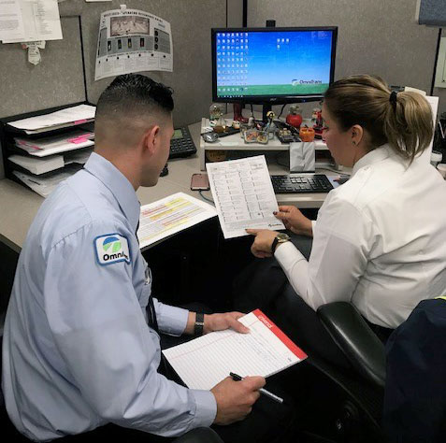

### *Above, a coach operator is given a ride check evaluation.* *Trainers interview coach operators after each ride check to ensure safety standards are being upheld. Additional training and/or accident prevention workshops can be scheduled when areas of concern or a preventable accident occurs. Below, Bill Parsons of Roadworthy Communications instructs during an ATCR class at Omnitrans. His “Verbal Defense from the Seated Position” presentation was a valuable lesson to our coach operators on customer service, verbal de-escalation techniques and transit safety.*

### 

### Audible turn signal program:

Omnitrans has installed an audible turn signal program to warn pedestrians when a bus is turning in close proximity. It announces in English and Spanish “Caution, bus is turning.” Another feature that was installed as an added safety measure is a light to warn pedestrians who may be wearing I-Pods, ear buds or have a hearing disability. As the bus turns, the strobe will light up in conjunction with the audible warning announcement to give a visual, as well as an audible, warning to those on sidewalks, crosswalks, or in the immediate area.

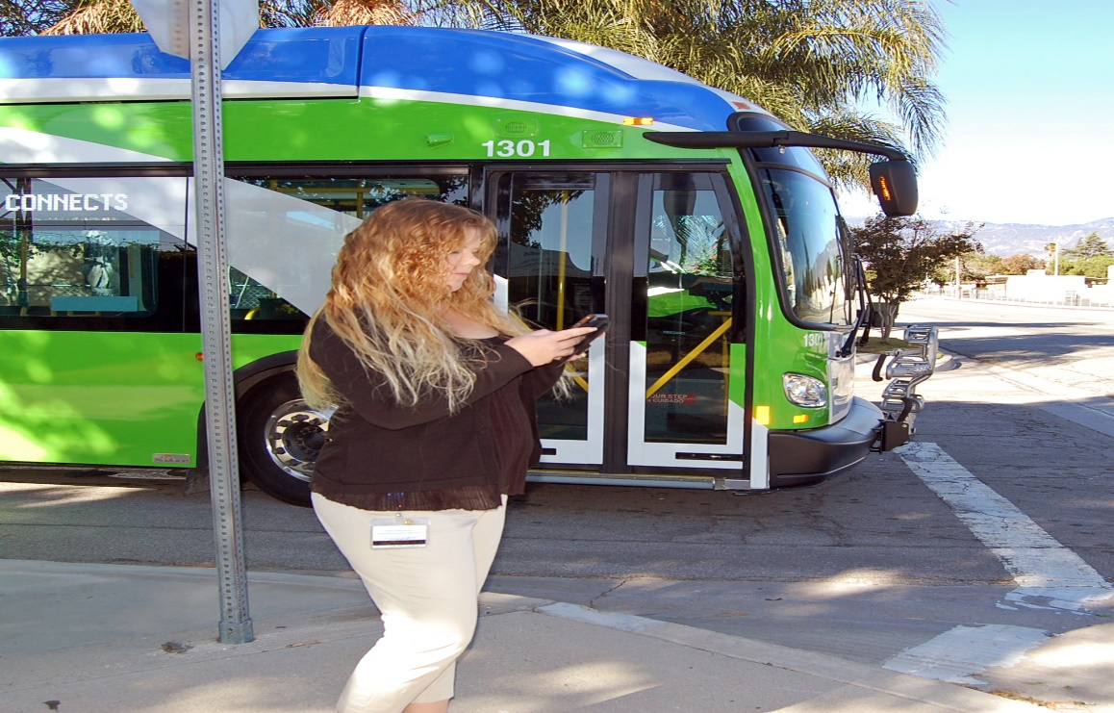

“**Caution, bus is turning!”**

1. **Allison Transmission programming:**

Four low speed collisions occurred after the purchase of New Flyer coaches, Omnitrans’ fleet was equipped with Voith transmissions in the past which prevented the coach from rolling after a positive stop. The agency’s Maintenance Department programmed the new transmissions to automatically enter neutral mode to prevent the coach from rolling forward after a positive stop. The coach stays in a neutral mode until the accelerator is pushed, which puts the coach in forward gear again. Since the neutral programming change, zero incidents have occurred.

### Improved Mobility Device Securements: Q-POD & Rear Facing Securements

Omnitrans has recently upgraded its mobility securement systems to enhance safety for disabled customers. The agency has upgraded from the four-belt Q-Straint system to the Q-Pod three-belt ratcheting securement system and a rear-facing securement station. When the system is properly secured by the coach operator, the mobility device is securely tightened to the side wall - prohibiting tipping. The rear facing station allows customers using a mobility device to easily access the securement area by backing into the padded backrest, setting the brake or powering off their mobility device, and lowering the restraining bar. A belt to attach to the restraining bar to prevent rolling inside the securement area also has been added for additional customer safety. No accidents have occurred since the Q-Pod system was installed.

### 

### Safety Camera Innovations:

**Mobileye:** Omnitrans is beginning a pilot program for the new Mobileye early collision avoidance system. The Mobileye Advanced Driver Assistance System provides driver protection to help avoid accidents, via early warning device. The Mobileye system is specifically designed to keep employees, pedestrians, and other motorists safe, as coaches drive designated routes in our service area. Even the most careful drivers benefit from an extra set of eyes on the road – which is exactly what this system is designed to do. Below is a chart showing the many challenges a transit coach making a left turn can face at an intersection. Mobileye cameras can detect movements in blind spots that may be missed by a coach operator trying to scan all the various hazards, as illustrated in the example below.

### 

### 

### Transit Center and Bus Yard Safety:

### Omnitrans’ state-of-the-art San Bernardino Transit Center is the busiest in the area, providing service to over five thousand passengers daily. The agency averages approximately 70,410 bus departures from all of its facilities each month. At these locations, safety is our top priority. We have several procedures are in place to ensure the safety of our employees and the public. A maximum speed of 5 mph at transit centers and bus yards is posted, and strictly enforced. In addition, the agency has added solar-powered radar signs with 4x8 foot digital messages and speed displays. All staff, security, vendors and guests are required to wear safety vest while in bus yards, transit centers, fueling/wash stations, garage areas, and in the field. The use of cell phones or other distracting devices is prohibited in our bus yard.

### 

### Recently, Metrolink has extended train service to the San Bernardino Transit Center. This service allows customers to extend their commute from deep within the Inland Empire, to Los Angeles and as far south as San Diego. In the near future, Omnitrans will add Arrow commuter rail service (image below) to points east to the city of Redlands.

### F:\Arow rail photo.jpg

### Travel Training Program

Omnitrans started the travel training program video and traveling presentation to serve a number of key audiences: senior citizens, people with disabilities, students, commuters, and Spanish-speaking community members with limited English proficiency. To date, the program has reached thousands of community members to introduce them to the benefits of transit and how to ride.

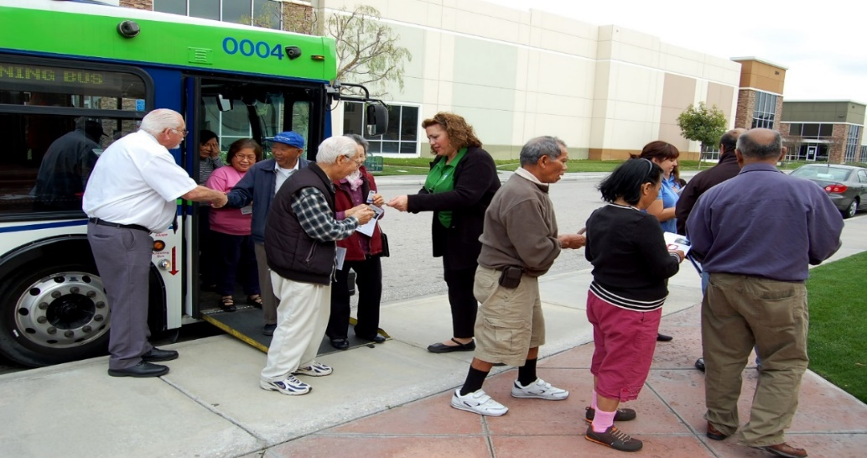

### Safety Campaigns:

### Omnitrans has implemented monthly safety campaigns to address hazardous trends noted through its tracking systems. These include:

### Distracted driving- is a significant problem with all motorists. Increased fines by law enforcement and laws designed to reduce cell phone use and other distracted driving practices have only limited success. Omnitrans has a safety program to discourage the use of electronic devices while operating agency vehicles. Of course, cell phones aren’t the only tools that can distract a driver - eating, drinking beverages, and unnecessary conversations can also compromise driving skills. Distracted driving in any form is not tolerated.

### Pedestrian awareness- is always a top safety priority for Omnitrans. The audible turn signal and Mobileye projects are being implemented to avoid bus vs. pedestrian accidents at all costs. Trainers have also added instruction modules to annual training to bring awareness to pedestrian safety.

### Night driving- there are many risks associated with driving a transit bus during hours of darkness. Reduced lighting, shadows and glare are just a few of the obstacles that can decrease visibility and reaction time for a coach operator. Omnitrans has promoted night safety ride checks, skills improvement workshops, and vehicle training during hours of darkness to instill good driving habits for staff. Reduced speeds, keeping your eyes moving, and proper rest are critical to safe driving at night.

### Bicycle safety- bicyclists can share the road with other vehicles, which makes them particularly vulnerable to accidents. The new “three feet for safety” law for bicyclists has been introduced, but Omnitrans policy goes further and instructs coach operators to keep at least four and one-half feet from bicyclists and to give a polite horn when passing.

### Performance Improvement program (P.I.P.)- Coach Operators are selected to attend a Performance Program workshop due to receiving negative customer contacts. The workshops provide insight to improve customer service skills which includes the joint effort of Training, Customer Service and Safety departments.

### A Strong Safety Culture = Reduced Accidents:

### Creating a strong safety culture takes a lot of hard work and persistence. Rule enforcement, discipline, and re-training all play a role in reducing accidents and promoting safer driving habits. The results are well worth the work in the form of reduced accidents. Industry standard is 1.0 preventable accidents per 100,000 miles. In 2013, Omnitrans’ preventable accident rate stood at 1.15 preventable accidents per 100,000 miles. Through persistent efforts and ongoing safety improvements, the agency’s preventable accident rate has been reduced consistently over the past five years. We have maintained a preventable accident rate between .74 and .81 per 100,000 miles from 2014 through 2018. This is a consistent reduction of over 32% during this five-year period!

**Omnitrans**

**2019 APTA Bus Safety & Security Excellence Awards**

**(Supporting Documentation & Information)**

|  |  |  |  |  |  |
| --- | --- | --- | --- | --- | --- |
| Fiscal Year | Revenue Miles | Preventable accidents | Avg. miles between preventable accidents | % Per 100,000 miles |  |
| 2012 | 8,250,367 | 95 | 86,845 miles | 1.15 |  |
| 2013 | 8,224,816 | 61 | 134,833 miles | 0.74 |  |
| 2014 | 8,234,501 | 64 | 128,664 miles | 0.80 |  |
| 2015 | 8,709,845 | 67 | 129,997 miles | 0.78 |  |
| 2016 | 9,151,066 | 74 | 123,663 miles | 0.80 |  |
| 2017 | 9,034,618 | 74 | 122,089 miles | 0.81 |  |
| 2018 | 9,519,514 | 76 | 125,256 miles | 0.80 |  |